ENY 1002C: Principles of Entomology
Valencia College West

Instructor: Dr. Denise DeBusk
Phone: (407) 582-5100
Email: ddebusk@valenciacollege.edu or through Canvas email
Modality: Online
Student Engagement Hours:
- Monday-Wednesday 9:30am-12:30pm (online)
- Thursday 12-1:30pm (on campus)
- Friday 1-2:30pm (online)
Credit Hours: 3
Prerequisites: This course does not require any prerequisites.

Welcome to the Course!
Entomology is the study of insects, including their relationships with other animals, their environments, and human beings. Insects outnumber all other forms of life combined and perform functions vital to life on earth. Consequently, entomologists make many important contributions to scientific knowledge, such as the best ways to pollinate crops, conserve insect species, and protect crops, trees, wildlife, and livestock from pests. Understanding the roles insects play in their environments can also help us restore disturbed ecosystems and clean up contaminated sites. When growing plants, being able to identify insects and understand their life cycle can allow us to better manage them and their damage.

Course Information

Course Description
This course involves the discussion of major plant insect pests, their characteristics, identification, life cycles and type of injury inflicted and analysis of various control measures including cultural, biological and chemical methods. It also includes pesticides, methods of application and precautions in handling.

Course Outcomes
There are several broad learning goals we will help you achieve by the end of this course. Specifically, you will:
- Describe the basic biology, structure, and function of insects.
- Identify major insect orders found in the environment.
- Describe categories of beneficial and pest insects.
- Describe the strategies of and design an integrated pest management program.

Textbooks
Although no textbook is required, there are some inexpensive optional books. I recommend getting Backyard Bugs to help you with the photo insect collection. It identifies the most common arthropods in Florida and lets you know where you can find them (in the air, at night, on the ground, etc.). The Photographic Atlas of Entomology and Guide to Insect Identification will be helpful to use for your activities. The Insects: An Outline of Entomology book is optional to purchase and there is a free pdf included in the class.
- Daniels, J.C. (2017). Backyard Bugs. Adventure Publications. (ISBN: 978-1-59193-685-5) (recommended)
- Castner, J.L. (2000). Photographic Atlas of Entomology and Guide to Insect Identification. Feline Press, Inc. (ISBN: 978-0962515040) (optional)
- Gullan, P.J. (2014). The Insects: An Outline of Entomology. Wiley-Blackwell. (ISBN: 978-1118846155) (optional)

Valencia College Core Competencies
This course seeks to reinforce the following Valencia Student Competencies: Think clearly, critically and creatively by analyzing, synthesizing, integrating and evaluating symbolic works and truth claims. Reflect on your own and others’ values from individual, cultural and global perspectives. Communicate by reading, listening, writing and speaking effectively. Act purposefully, reflectively and responsibly by implementing effective problem solving and decision making strategies.

Our Inclusive Learning Environment
Your success in this class is important to me. We all learn differently and bring different strengths and needs to the class. We expect everyone in this class to contribute to a respectful, welcoming, and inclusive environment to support the learning of all other members of the class. If there are aspects of the instruction or design of this course that result in barriers to your inclusion or accurate assessment or achievement, please let me know as soon as possible.
If you have a disability and require accommodations, please let me know during the first two weeks of the semester. You will need to register with the Office for Students with Disabilities (OSD) (West Campus SSB 102, 407-582-1523). OSD determines accommodations based on appropriate documentation of disabilities and provides a letter to me with them.

What to Expect in this Class?

Teacher Expectations
I believe that anyone can succeed in the class if the right learning environment and strategies are used. I have structured this course to provide a variety of learning assessments with diverse learners in mind. I value your uniqueness and experience and want you to value your classmates as well. We are all learning together so please reach out to me if you have any questions or need extra assistance. I am here to help you learn.
- I will follow the course outline as closely as possible and will notify you of modifications in the outline if they happen.
- I will attempt to create and maintain a classroom atmosphere in which you feel free to both listen to others and express your views and ask questions to increase your learning. I like to see the class as a community.
- Please email me or schedule a Zoom meeting if there is anything you want to discuss or about which you are unclear. I want to be supportive of your learning and growth.
- I will provide feedback/grades within a week (7 days), often earlier, on the submitted assignment. It will be posted to the Canvas Gradebook.

Student Expectations
Set goals for yourself for this course and plan/work to meet them. Meet all course deadlines and you will receive feedback within a week on the submitted assignment. Value your classmate’s opinions and be open to learn new ways of thinking. Complete all assignments, exams, and projects without sharing/copying other’s work or answers and be proud of your work.
- Please inform me by email if there is something that prevents you from turning in assignments.
- You are expected to check your Atlas email and Canvas inbox on a regular basis throughout the week.
- Since this is an online class, all of it is spent at the comfort of a computer, you can expect to devote 3-6 hours each week to this course.
- Feel free to share feedback regarding how well the class is meeting your needs or if material is unclear. I make changes to the class based on feedback, either on the spot or in the future.
- It is also expected that you will treat classmates with respect and observe the rules of confidentiality regarding personal information shared in class.

How your Learning will be Assessed?
All assignments will be turned-in according to the schedule outlined in the course calendar.
Video Guides: Video guides include questions from the videos that will assist you in studying for the quizzes. I include scripted PowerPoints with each video since certain people learn in different ways. It is expected that your answers for your video guides will be in your own words or paraphrasing what I provide. Do not copy and paste paragraphs or sentences from the PowerPoint script. The best way to learn is to handwrite the answers and take a photo of your video guide, although you can type your answers.
Activities: Activities are designed to enhance the online material by giving you practical experience and examples. Activities are graded for completion, but questions on the exams will be drawn from the activities.
Quizzes: Quizzes help reinforce the information covered. You will have online quizzes on each topic. It will consist of multiple-choice, true/false, and matching. Each quiz will have a time limit of 20 minutes. Quizzes will be due the following Wednesdays. You need to download Respondus Lockdown Browser to take the quizzes. Your lowest quiz grade will be dropped.
Projects: You will be required to complete two projects.
- Greenhouse Biological Control Project: You will choose a pest (from list) to devise an integrated pest management plan. You will create a PowerPoint presentation and submit it. You will also review other presentations and reply about what you learned.
- Crop Pest and Beneficial ID Cards: You will choose a cropping system, such as landscape, nursery ornamentals, fruit trees, agronomic crops, vegetables, greenhouse ornamentals, etc. and research the types of pests (insects or mites only) and beneficials in that system. You will create identification cards for those organisms in a PowerPoint or Word document.
Insect Collection: Every student is required to submit a photo insect collection in lieu of a final exam. You will need to take photographs during the semester. A mini collection of 5 insects is due mid-way in the semester to check that it is done properly. The final collection requires 15 different insects that are properly identified and classified.
Extra Credit: There are extra credit activities on most of the topics worth 1 point each on your quiz score. These are a great review for the quizzes and recommended to do. You can also get extra credit for completing your Student Feedback at the end of the semester.
Late Work/Makeup Policy: Since life sometimes gets in the way, your lowest exam grade will be dropped. Additionally, there is a two-week grace period after assignments are due (except for those assignments near the end of the semester). During this time, late work is eligible for partial credit (2% deduction per day). If there are extenuating circumstances, please contact me as early as possible to discuss your options.

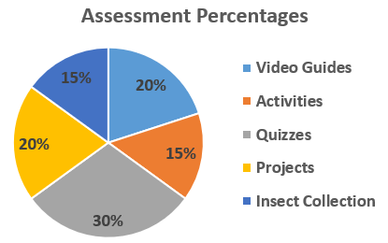
Grading Scale
A = 89.5-100%, B = 79.5-89.49%, C = 69.5-79.49%, D = 59.5-69.49%, F = below 59.49%
Your grade will be calculated as follows:
- Video Guides – 20%
- Activities – 15%
- Quizzes – 30% (lowest grade dropped)
- Projects (2) – 20% (10% each)
- Insect Collection – 15% (Mini-collection 5%)

TENTATIVE COURSE SCHEDULE
Week | Online Topic | Wednesday Activity | Sunday Activity
Jan 8-14 | Orientation |  | Orientation Quiz*  Be in the Know Assignment* Introduction Discussion
Jan 15-21 | Introduction to Entomology |  | Video Guide  Eyewitness Insect Video Quiz
Jan 22-28 | Insect Classification | Quiz 1 | Video Guide  Who am I? Activity
Jan 29-Feb 4 | Metamorphosis, Growth & Development | Quiz 2 | Video Guide  Activity: Insect Development and Management
Feb 5-11 | External Morphology | Quiz 3 | Video Guide  Activity: External Anatomy Lab
Feb 12-18 | Internal Morphology | Quiz 4 | Video Guide  Activity: Insect Dissection
Feb 19-25 | Insects as Pests | Quiz 5 | Video Guide  Activity: Florida Invasive Insects
Feb 26-Mar 3 | Integrated Pest Management | Quiz 6 | Video Guide  Mini-Collection
Mar 4-10 | Chemical Control | Quiz 7 | Video Guide  Activity: What Pesticide is this?
Mar 11-17 | Greenhouse Pest Management Project | Quiz 8 | Greenhouse Pest Management Project
Mar 18-24 | Spring Break
Mar 25-Mar 31 | Ground-Dwelling Insects and Aquatic Insects |  | Video Guide  Activity: Aquatic Insect Adaptations
Apr 1-7 | Insects and Plants | Quiz 9 | Video Guide  Crop Pest and Beneficial ID Cards
Apr 8-14 | Insect Societies and Predation and Parasitism | Quiz 10 | Video Guide  Activity: Colony Collapse Disorder Curation
Apr 15-21 |  | Quiz 11 | Final Insect Collection
Apr 22-25 |  | Insect Collection (late days)
Bold = summative assessments (based on correctness) * = required to get into modules

Vacations and other important dates
- Jan 8 – Classes begin
- Jan 16 – Drop/Refund Deadline
- Mar 15 – Withdrawal deadline
- Mar 18-24 – Spring Break (no classes)
- Apr 28 – Term ends

How can you Contact Me?
You may contact me in various ways during this semester.
- You may contact me through the Canvas Inbox. This is probably the best and quickest method of communication. I will respond to your message within 48 hours, often much sooner, with the exception of days and times when the college is closed.
- You may email me at ddebusk@valenciacollege.edu. In your messages (if not using the Canvas Inbox), please indicate your course number so that I may better assist you.
- You may schedule to meet me in my office when I’m on campus.
- If you prefer to speak to me directly, my Valencia phone number is (407) 582-5100, and I will be happy to make an appointment with you.

What Policies are in the Course?
No Show Policy
Since this is an online class, attendance is counted as assignments submitted. The Orientation Quiz is the required attendance activity for the first week. You need to complete the activity to show that you are attending the course. If you do not complete that activity by the end of the week, you will be withdrawn from the class as a “no show.” You will still be financially responsible for the class and a final grade of “WN” will appear on your transcript for the course. If you are unable to complete the Orientation Quiz during the first week, notify me as early as possible and we can discuss your options. If you are not planning to continue the class, make an effort to drop the course before the deadline.

Attendance Policy
This is an online course, available 24/7, managed through Canvas. You must have access to the Internet (available on all Valencia campuses) to complete the course requirements. Your online attendance will be checked based on your participation in the course and submission of coursework. In the event of an extended absence, you should contact me so that we can discuss your options. If you do not submit any assignments for two weeks, I will email you about your absence. If I don’t get an email back within a week explaining your absence, I will withdraw you from the class. If you contact me but do not begin completing work, you will be withdrawn after another week. After the withdraw deadline, students with an absence of more than 2 weeks will receive the final grade that is earned according to the course grading policy.
Withdrawal
The deadline for Drop/Refund is Jan 16th and for Withdrawal is Mar 15^{th.} Per Valencia policy a student who withdraws from class before the established deadline for a particular term will receive a grade of “W. A student is not permitted to withdraw after the withdrawal deadline.
If you are withdrawn, you will receive a grade of “W”. This can affect you financially and cause problems with any future financial aid you receive. After the withdrawal deadline, I will not withdraw you and you will receive the grade earned at the end of the course. If you withdraw from a class during a third or subsequent attempt in the same course, you will automatically be assigned a grade of “F.” If you do not intend to complete the course, you must withdraw yourself prior to the withdrawal date. Prior to withdrawing, please reach out to me to discuss your situation.
Academic Integrity
Valencia College is a community of scholars committed to the values of integrity. In this community, all members including faculty, staff, and students alike are responsible for maintaining the highest standards of academic honesty and quality of academic work. As a student and member of the Valencia College community, you are expected to demonstrate integrity in all of your academic endeavors. Unacceptable behavior include cheating, fabrication, plagiarism, using unauthorized study aids, or facilitating academic misconduct. Please review our campus policy on academic integrity.
All work submitted by you is expected to be the result of your individual thoughts, research, and self-expression. Whenever you use ideas, wording, or organization from another source, the source shall be appropriately acknowledged. Copying and pasting from an online source without paraphrasing the information first, even if providing a reference, is still considered plagiarism. If too much of your work is similar, I will allow a rewrite for up to 50% of the assignment score for the first offense. A second offense will result in a zero score on the assignment and a third offense will result in a class grade of F. Take advantage of the project check-ins to receive feedback on your writing. As an alternative to the 50% rewrite, you can resubmit your work within the grace period with the partial point deduction.
College Student Conduct Policy
Valencia is dedicated not only to the advancement of knowledge and learning but also to the development of responsible personal and social conduct. As a registered student, you assume the responsibility for conducting yourself in a manner that contributes positively to Valencia’s learning community and that does not impair, interfere with, or obstruct the orderly conduct, processes, and functions of the college as described in the Student Code of Conduct.

Netiquette
It is important to be aware of your behavior in an online learning environment to ensure positive interactions with your instructor and peers. This requires you to follow some guidelines for behaviors.
All students are expected to:
- Show respect for the instructor and for other students in the course
- Respect the privacy of other students
- Express differences of opinion in a polite and rational way
- Maintain an environment of constructive criticism when commenting on the work of other students
- Remain focused on the learning topics during discussions and activities

Third Party Software & FERPA Policy
Valencia College has a firm commitment to protecting the privacy rights of its students. Under no circumstances will your test scores, total points, or final grades be discussed on the telephone or over e-mail. FERPA rights to privacy prevent the divulging of scores or related materials by these means. Access your scores through the Canvas gradebook.

Student Resources for Support and Learning
As a Valencia College student, you may experience challenges such as struggles with academics, finances, or your personal well-being. Valencia College has a multitude of resources available to all students. Many of these resources are listed below and we encourage all students to explore them as needed. If you are experiencing a mental health emergency please contact 9-1-1 or BayCare Behavioral Health at (800) 878-5470.
- Student Assistance Program: Valencia students can get immediate help with issues dealing with stress, anxiety, depression, adjustment difficulties, substance abuse, time management as well as relationship problems dealing with school, home or work. BayCare Behavioral Health Student Assistance Program services are free to all Valencia students and available 24 hours a day by calling (800) 878-5470. Free face-to-face counseling is also available.
- Valencia Counselors: Valencia counselors care about your emotional well-being so they offer both virtual and in-person options to connect with students. Connect to counselors through the student support form.
- Pooky’s Pantry: It is a free resource that offers non-perishable food items, hygiene items, socks, outside resource information, and local housing information. There are locations on each campus.
- Advising: The advisor for the Plant Science and Agricultural Technology program is Gabi Cerda. She can be reached at gcerda@valenciacollege.edu or 407-582-1108. She is a great resource for questions about classes, degree programs and certificates, graduation, and transferring to a university.
- Learning Support: Learning Support Services provides students with academic support through distance tutoring, face to face tutoring at the campuses, writing consultations, library services, and resources. Tutoring is offered in most academic disciplines including math, science, foreign languages, English for academic purposes (EAP), computer programming and writing assistance for any course. For more information on how to access tutoring and library research assistance, please visit the college-wide Learning Support Services LibGuide.
- Skillshops: Skillshops are free workshops, or mini courses that provide real-life solutions to common student issues.
- Career Center: Don’t wait until your last year – visit the career center today!
- Library: At each campus library, librarians and other qualified staff can assist students with searching and finding items and information, MLA and APA citations, and technologies. The library provides a variety of books, eBooks, online articles, textbooks, DVDs and streaming videos to support course-related research and other learning needs. View the Library website for more information.

How to Succeed in this Course?
There are many ways for you to show us what and how you are learning, through your effort, interaction and class participation, application of scientific thinking to solve real world problems, and performance on assignments and quizzes. This class has been structured to help all students get the support and guidance needed to succeed in your learning. The below graphic is how the class is structured to best facilitate learning. If you skip ahead, such as missing an activity because it will take too long, this breaks the chain in understanding and you may not do as well on the quiz or your project. If you miss the project check-ins then you may receive a grade that you weren’t expecting because you misinterpreted the rubric. The following tips will help you be successful in this class and in other classes throughout your career at Valencia College.
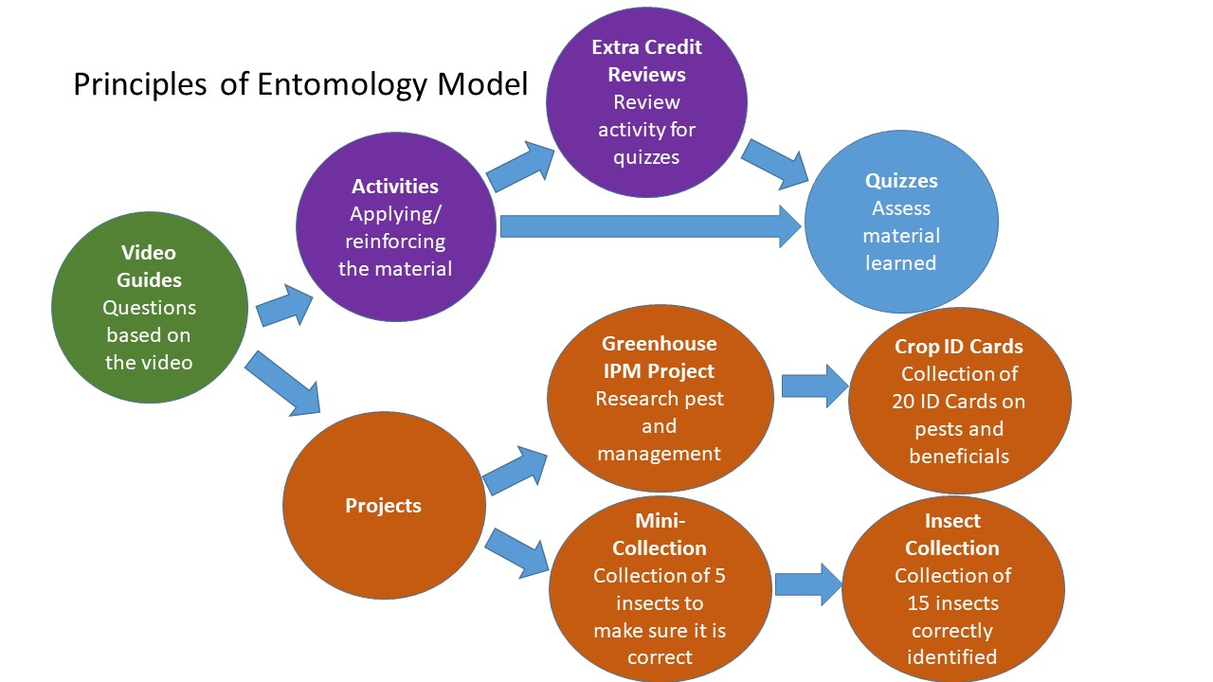
- “LEARNING” IS AN ACTION VERB!! Most students need to do more than just watch lectures and reread their notes. Spend 1-2 hour blocks of time several days a week actively writing or discussing concepts to make them a part of your memory. Use the words you learn often, they will sink in better.
- Check Canvas every other day and change your settings so you are getting the notifications for announcements and submission comments in your email. You don’t want to miss an important announcement or extra credit opportunity.
- Progress through the modules rather than relying on the to-do list on Canvas. The module is set-up to guide you through material and increase mastery of the information.
- Do the extra credit activities! These interactive activities have been specifically designed to complement the exams, so they are a great review. If you get 75% correct, you get a point. If you get less, then you get a 0.5 point. Open book and no pressure.
- Make to-do lists and prioritize tasks. Record all the things you need to accomplish then focus on completing one task at a time. Prioritize your task based on the most critical and time-sensitive ones. You can use paper to-do lists or an app. Don’t forget to reward yourself for a job well done once tasks have been successfully completed.
- Eliminate distractions so your attention is on the task-at-hand. You will finish tasks and move on to the next ones more quickly while paying more attention to details. Turn off the TV, put your phone on silent, and keep your study area organized.
- Take good notes and make flash cards. Record the key points of the video or lecture and answer your video guides without writing down too much extraneous information. Flash cards are great for all the new terminology.
- Take a break. Take a 10-15 minute break each hour or a 5-minute break after every 20 minutes of studying. This will prevent you from burning out too soon and you are more likely to retain the material compared to studying 3 hours straight. Good break options include listening and singing to a song, taking a walk, or getting a snack.
- Ask questions. Make lists of confusing topics from your studying and ask questions (as many as you can!). Talking to your professor helps you as well your professor to refocus on the topic again.

